Everest Engineering College

5/14/2023

**Submitted By**

Hari Narayan Chaudhary ( 20070289)

Dipin Pokhrel (20070287)

Prajwol Dangol (20070301)

Pradip Ramtel (20070298)

A Proposal on “Movie Tickets Booking System”

[Document subtitle]

**Submitted To**

The Course Instructor (Birodh Rijal)

Object Oriented Software Engineering (OOSE)

Department of Computer Engineering

**Document Control**

Document Information

|  |  |
| --- | --- |
|  | **Information** |
| Document Id | *[Project Name short form #]* |
| Document Owner | *[Owner Name]* |
| Issue Date | *[Date]* |
| Last Saved Date | *[Date]* |
| File Name | *[Name]* |

Document History

|  |  |  |
| --- | --- | --- |
| **Version** | **Issue Date** | **Changes** |
| *[1.0]* | *[2023-05-]* | *[Section, Page(s) and Text Revised]* |
|  |  |  |
|  |  |  |
|  |  |  |

Document Approvals

|  |  |  |  |
| --- | --- | --- | --- |
| **Role** | **Name©** | **Signature** | **Date** |
| Project Supervisor | Birodh Rijal |  |  |
| Project Member 1 | hari Narayan chaudhary |  |  |
| Project Member 2 | Dipin Pokhrel |  |  |
| Project Member 3 | Prajwol Dangol |  |  |
| Project Member 4 | Pradip Ramtel |  |  |

Table of Contents

Executive Summary 2

1. Introduction 3

1.1 Background of the Project 3

1.2 Introduction to the project 3

1.3 Objective 3

This section describes the measurable outcome of the proposed solution. 3

1.4 Scope 3

2. Methodology 4

2.1 Block Diagram 4

2.2 System Architecture 4

2.3 Project Team 4

2.4 Deliverables 4

2.5 Project Timeline 4

2.6 Project Risks and Issues 5

3. Result 7

3.1 System Testing 7

Describe how you are going to test your System. 7

4. Success Criteria 7

5. Appendix 8

5.1 Supporting Documents 8

# Executive Summary

The project is a web application using XAMPP with Apache server. Frontend: HTML, CSS, Bootstrap, JaveScript. Backend: Python with MySQL database. It has an admin panel for movie management and a customer panel for theater selection, movie browsing, and ticket booking. JaveScript handles front-end validation. Optimizing the back end is the main challenge. Web app for easy ticket booking from anywhere, eliminating the need to visit cinemas or wait in queues. The project will be completed within the time frame we have divided according to our effective time. The system aims to revolutionize ticket booking by providing users with a convenient and user-friendly platform. Users can browse movies, access detailed information, and effortlessly book tickets without the need to visit cinemas or endure long queues. The system ensures optimal performance, with fast response times and the ability to handle a large number of concurrent users. Usability is prioritized through an intuitive interface, making the ticket booking process seamless. Security measures protect user data and payment information, while authentication and authorization mechanisms ensure authorized access. Regular communication with stakeholders keeps them informed about project progress, ultimately delivering a robust and satisfying ticket booking solution for both users and cinema administrators.

# Introduction

## Background of the Project

We make this project as web application. The issues we all going to face is in the backend part. The more we optimize this application the more it going to be challenging to us.

## Introduction to the project

This movie ticket booking system project in Python focuses mainly on dealing with customers, theatre management regarding their bookings, and other parts of the management side. Also, the system allows customer is login or register if he/she does not have and account for booking stuff. The project is divided into three categories: Client-Side, Admin panel, and Theatre Panel. In an overview of this website (referring to client-side), the customers can view the numbers of available movies, upcoming movies, and top movie trailers of each. Talking more about the project, the system displays show details of each if available, then the customer can simply select show timing and number of tickets for proceeding towards the payment section. After all this process, the customer can view his/her booking history with a booking ID, name of the movie, number of tickets, and total ticket amount.

## Objective

## To make easy to book ticket at home and form anywhere without visiting cinema and waiting in a long queue.

## Scope

* This project we have carried out was a learning curve for us in development of such systems.
* In future we can scale this project by adding different dynamic interfaces for different mobile.
* Allow users to add comments and subsequent.
* Allow users to rate movies after watching them in the theatre.

# Methodology

## Block Diagram

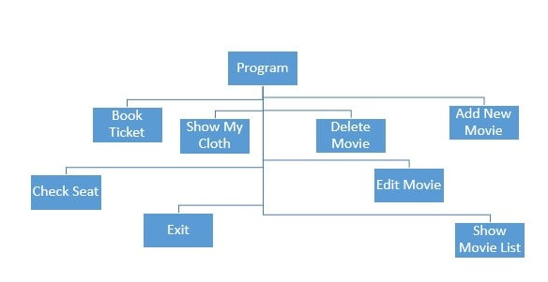

Fig : block diagram

## System Architecture

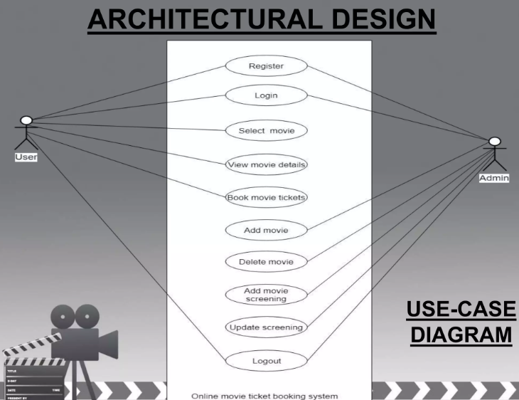

Fig: Architecture design

## Project Team

Describe Project team members, their roles, their anticipated input in weeks.

|  |  |  |  |  |
| --- | --- | --- | --- | --- |
| SN | Name | Role | Effort ( weeks) | Duration |
| 1 | Birodh Rijal | Team Lead | 10 | 10 |
| 2 | Hari Narayan Chaudhary | Back-end | 10 | 10 |
| 3 | Dipin Pokhrel | Front-end + documentation | 10 | 10 |
| 4 | Prajwol Dangol | Front-end | 10 | 10 |
| 5 | Pradip ramtel | Front-end | 10 | 10 |

## Deliverables

Every project produces deliverables which form part of the solution that solves the business problem or opportunity.

|  |  |  |  |
| --- | --- | --- | --- |
| SN | Name | Description | Deadline |
| 1 | Project Proposal |  | Within one week of the starting of the project |
| 2 | SRS Document |  | By three Four of the starting of the project |
| 3 | Draft Report |  | By the 8 weeks of the starting of Project |
| 4 | Fina Report |  | By the 9 weeks of the starting of the project |

## Project Timeline

All projects must be delivered within a specific *timeframe*. The timeframe is described in terms of Gantt chart. The milestone and deliverables should be well specified in the Gantt chart.



## Project Risks and Issues

Risk and issues occur which try and prevent the project from producing the deliverables on time. Risks and issues are as follow: .

* ***Risks:***
* Developing and maintaining a robust online movie ticket booking system can present various technical challenges, such as ensuring system security against potential cyber threats.
* The online ticket booking system will handle sensitive customer data, including personal information. Ensuring strong data encryption, implementing robust authentication mechanisms, and protecting against unauthorized access or data breaches are crucial for maintaining customer trust.
* ***Issues:***
* The system’s performance could be a concern, especially during periods of high demand, such as weekends or blockbuster movie releases. Issues like slow loading times, system crashes, or unresponsive pages can frustrate users and negatively impact their experience.
* Designing, an intuitive and user-friendly interface if essential for enhancing the overall user experience. Issues related to confusing navigation, unresponsive buttons, or inadequate search functionality can lead to frustration and discourage users from using the system.

# Result

## System Testing

To test a system or project that we will built, we would typically follow a systematic approach that includes the following steps:

* **Identify testing objectives**: first, we would clarify the objectives of the testing process. This involves understanding what aspects of the system need to be tested, such as functionality, performance, security, or usability.
* **Plan Test Strategy**: Based on the identified objectives, we would develop a test strategy outlining the overall approach, test methods, and resources required. This includes determining the types of tests to be conducted (e.g., unit testing, integration testing, system testing) and defining the testing environments.
* **Design Test Cases**: Next, we would create test cases that cover various scenarios and functionalities of the system. Test cases are designed to validate specific aspects or features of the system and typically include inputs, expected outputs, and any prerequisites.
* **Set Up Test Environment**: To ensure accurate and controlled testing, we would set up a dedicated test environment that closely mimics the production environment. This might involve configuring hardware, software, and network settings according to the system requirements.
* **Execute Test Cases**: With the test environment ready, we would execute the test cases systematically. This involves running the tests, recording the results, and comparing the actual outcomes with the expected outcomes defined in the test cases. The execution phase may involve manual testing or automated testing, depending on the nature of the system and available resources.
* **Validate Non-Functional Requirements:** in addition to functional testing, I would also validate non-functional requirements such as performance, scalability, security, and usability. This may involve conducting load testing, stress testing, security testing, and usability testing, depending on the system’s specific requirements.
* **Document Test Results**: throughout the testing process, I would maintain detailed documentation of the test results, including the executed test cases, their outcomes, any issues identified, and overall testing metrics. This documentation serves as a valuable resource for future reference and for sharing the testing findings with stakeholders.
* **Evaluate Test Coverage**: I Finally I would evaluate the test coverage to ensure that an adequate number of test cases have been executed and that all critical functionalities and system components have been thoroughly tested. This helps in assessing the quality and reliability of the system.

By following the systematic testing approach, I can effectively evaluate the system’s performance, identify, and resolve issues, and ensure that it meets the desired requirements and standards.

# Success Criteria

Here’s some key success criteria, against which the project will be measured as follow.

**Functional Requirements:**

* The system should allow users to browse movies.
* User should be able to view detailed information about movies, including the plot, cast and ratings.
* The system should provide a user-friendly interface for managing ticket bookings.
* Admins should have the ability to manage movie listings, including adding new movies, updating showtimes.

**Performance Requirements:**

* The system should be able to handle a large number of concurrent users without significant performance degradation.
* Response times for browsing movies and making bookings should be fast and efficient.

**Usability Requirements:**

* The user interface should be intuitive and easy to navigate, allowing user to book tickets with minimal effort and confusion.

**Security Requirements:**

* The system should implement appropriate security measures to protect user data and payment information.
* User authentication and authorization should be in place to ensure that only authorized users can access and modify sensitive information.

**Stakeholder Requirements:**

* Regular communication and updates should be provided to stakeholders regarding the progress and milestones of the project.
* The system should meet the expectations and requirements of both end users and cinema administrators.

# Appendix

## Supporting Documents

Provide any documentation you believe supports this Project Proposal. It may be:

* Research materials
* Statistics or estimates
* Detailed cost / benefit spreadsheets
* Other relevant information or correspondence.